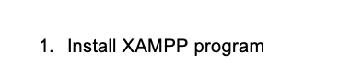

To download XAMPP click on this link: <https://www.apachefriends.org/download.html> and download XAMPP for Windows (64-bit). Select the PHP 8.0.7 / PHP 8.0.7 version, then the file will proceed to download automatically.

